Iteration 1

The component I will be trialling: The recipe menu

Version 1:

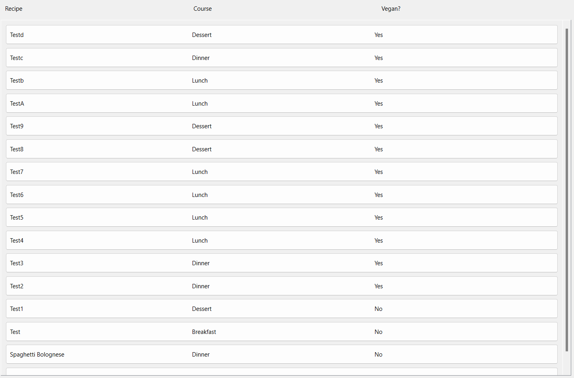

Feedback received:

Pros:

* The page is not very busy
* It’s useful to be shown that a food is vegan

Cons:

* In its unfiltered state the menu is not organized
* Courses could be colour-coded

Summary:

Rearranging the buttons (which do not store any data and I do not intend to make contain any data) to be more organized is beyond the scope of my programming prowess, and is th erefore non-negotiable. However, I can colour code the buttons and think that I will do this.

Version 2:

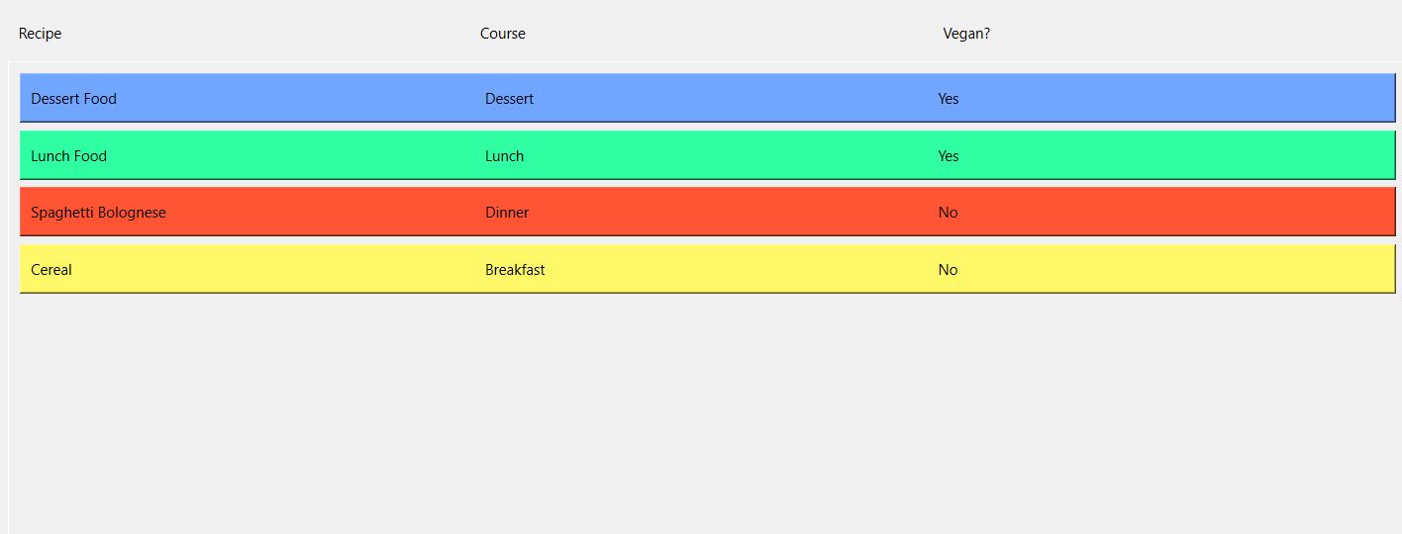

Pros:

* The Colours are good
* They don’t obscure the text

Cons:

* None

Summary:

No negative feedback was received, so this component is done.

The Component I will be trialling: The filtering menu

Version 1:

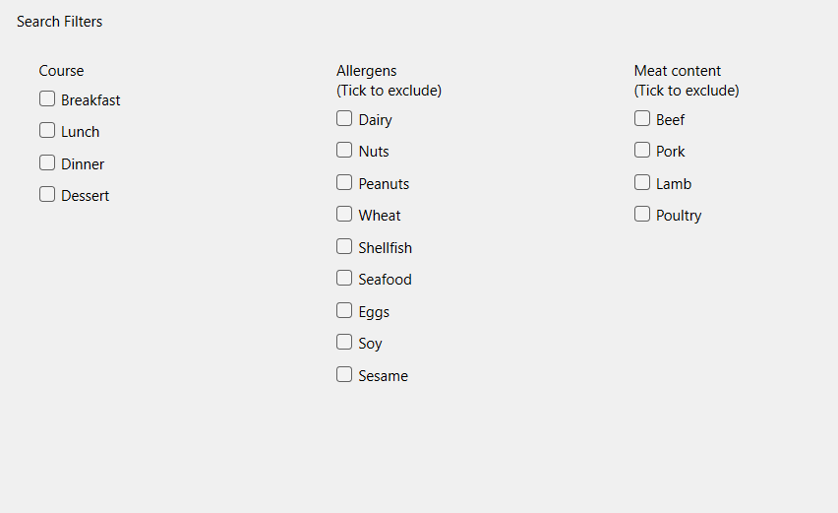

Pros:

* I like how they are laid out in columns
* The notation that clicking excludes recipes is good

Cons:

* Unchecking multiple buttons can be tedious, an “Uncheck All” button would be useful
* The Headings don’t stand out particularly

Summary:

I agree with the criticism this version received. Going forward I will add “Uncheck All” buttons and make the text for Headings more prominent.

Version 2:

Pros:

* The changes made are a definite improvement

Cons:

* None

Summary:

No negative feedback was received, so this component is done.